File name: Pulsed Power Calibration, v3

Date: 2016-3-11 by Yuchao

**End goal**: In pulsed mode, laser power is measured by a Judson MCT detector and feed into a Lock-in Amplifier for the reading. How to convert this value (in mV) and the actual **peak power** (in mW)?

# Starting Point

For a square pulsed wave, lock-in reading is expressed as: (see appendix for proof). For example, if an input voltage height is 1V, the duty cycle is 50%, and then the lock-in reading should be 0.45 V.

Ideally, if there’s no propagation loss, a laser peak power of P is 100% received by the detector, with a responsivity R, then the lock-in reading 

So ideally, **gideal=R*0.45, the unit is V/W**

Once we determine the value of g, we can quickly calculate the peak power by

 (1)

# Empirical

This way uses power meter to approach the peak power at 80K. However, the real peak power is also affected by several factors (cryostat window, divergence, heating effect). We can package all of these factors as ηPM, so the relation between peak power and power meter reading could be expressed as

, where c2 is the duty cycle of current source.

We ignore heating effect at 80K, and only consider window transmission loss and divergence loss into ηPM. In some case, heating effect could not be ignored, but it can be mitigated by using a pulsed current source with certain duty-cycle (10%~50%).

After getting two I-P curves at 80K by power meter and LIA respectively, g factor can be obtained as follows:

 (2)

To bridge the gap between the two g factor, decompose them into the source:



Please see Yuchao’s dissertation to explain this discrepancy.

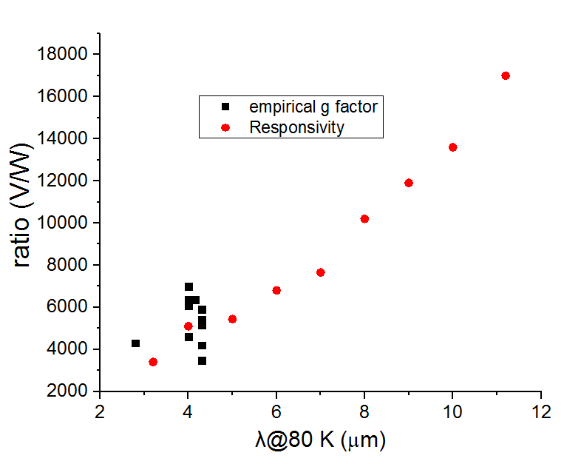

# Semi-empirical

In order to get a more analytical understanding of g factor and try to reveal the intrinsic physical process, a semi-empirical analysis will be helpful. Let’s begin with a schematic diagram.

## Schematic diagram

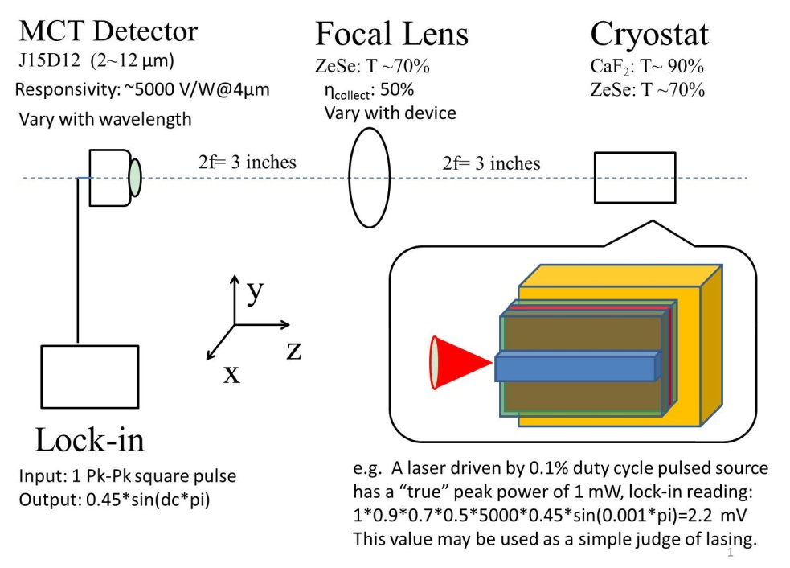

An estimate for g factor in the above schematic drawing is



Why experimental value is 5 times as high as analytical estimation?

# Responsivity and collecting efficiency

A more accurate g factor requires the following 2 corrections:

## 1, Responsivity~λ

Usually, we use Judson MCT detector (J15D12-M204-S01M-60) to get the pulsed power. With designed bias and matched pre-amplifier, the responsivity from the data sheet is as follows

|  |  |  |  |
| --- | --- | --- | --- |
| Wavelength  (µm) | relative response | Responsivity  (V/W) | estimate g factor  V/W=resp. *0.9 |
| 11.2 | 1 | 17000 | 15300 |
| 10 | 0.8 | 13600 | 12240 |
| 9 | 0.7 | 11900 | 10710 |
| 8 | 0.6 | 10200 | 9180 |
| 7 | 0.45 | 7650 | 6885 |
| 6 | 0.4 | 6800 | 6120 |
| 5 | 0.32 | 5440 | 4896 |
| 4 | 0.3 | 5100 | 4590 |
| 3.2 | 0.2 | 3400 | 3060 |

## 2, collecting efficiency by the 2f lens

### 2.1 setup and receiving angles

In our current setup, more photons are collected by the power meter than the lens.

Receiving angle by Lens with 2f away from cryostat: 31.45±0.4°

Receiving angle by Power meter: 48° ±2°

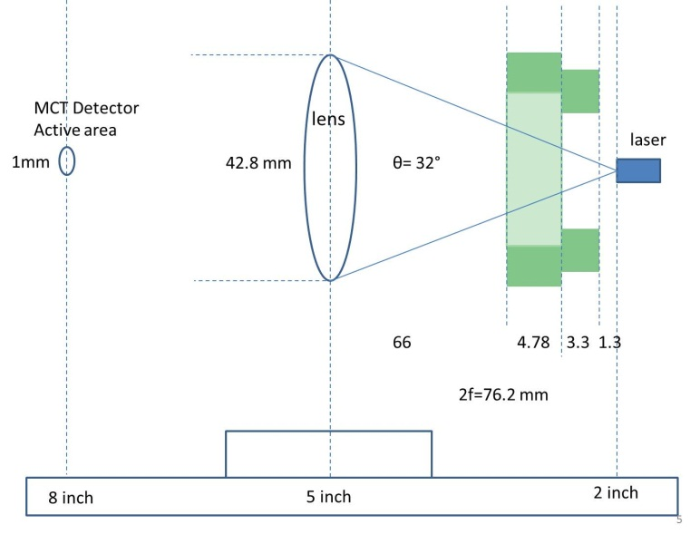 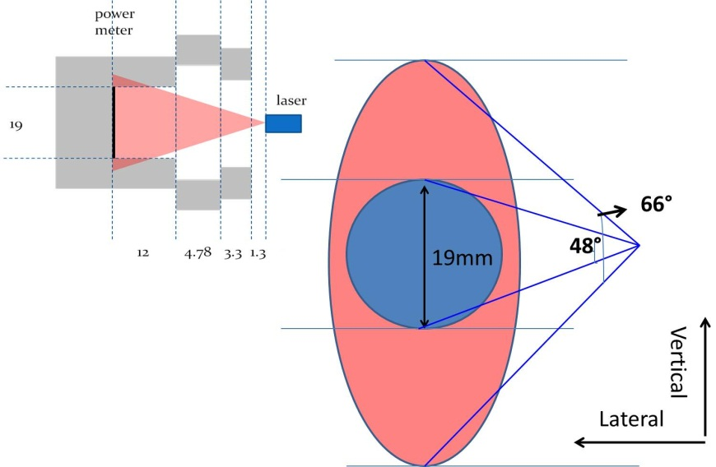

### 2.2 receiving ratios in experiments, 4 um

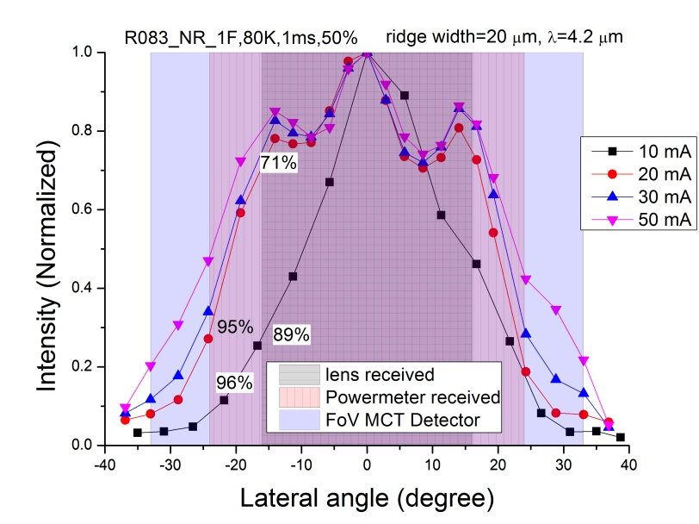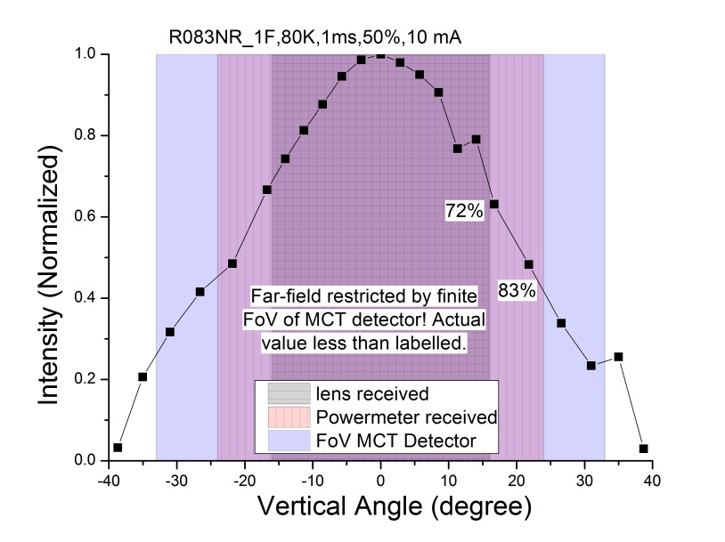

**Overall lens collecting efficiency** estimate: **50%** (< 80%*70%=56%)

**Overall power meter collecting efficiency** estimate: **75%** (< 95%*85%=81%)

So, if I put Power meter in the MCT position, the value should be at least half of the that when Power meter is put as close as the cryostat. (Verified by experiment, see below)

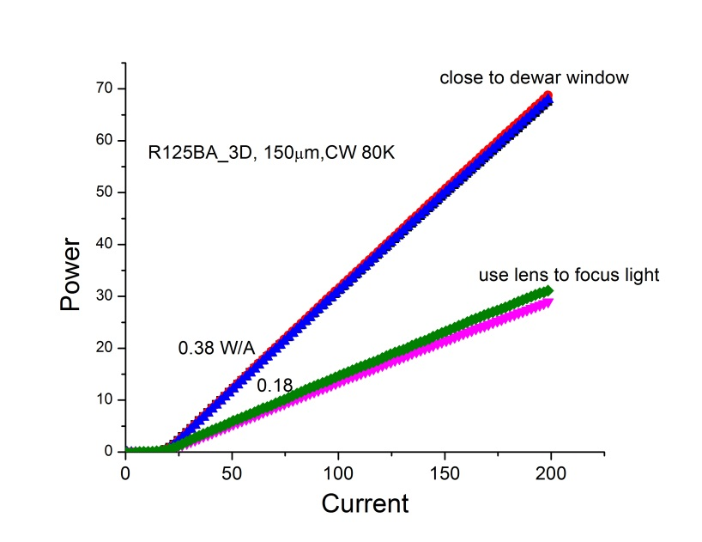 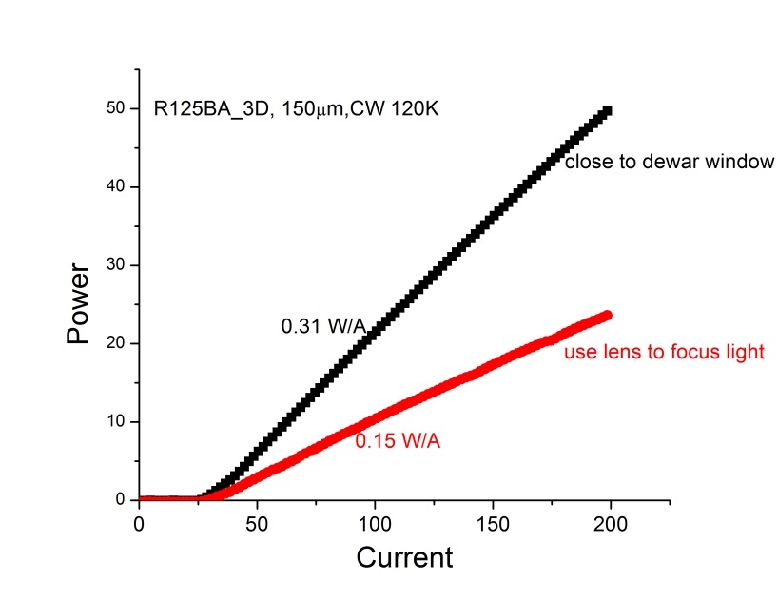

## g factor by zuowei

 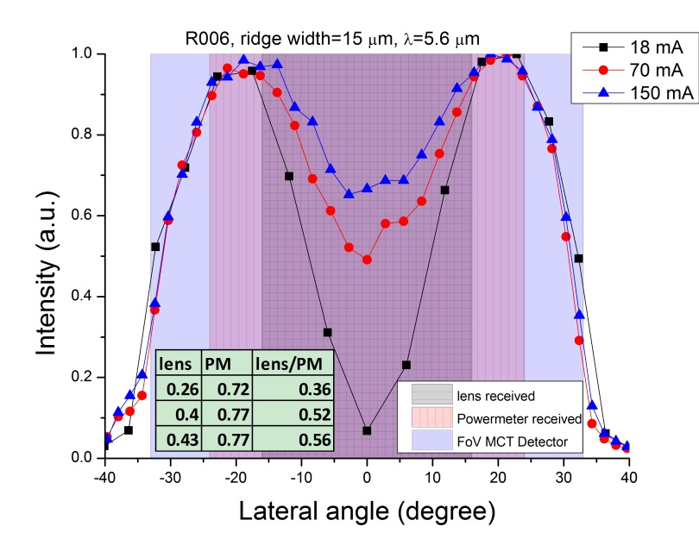

Now it is very clear that the opposite trend of g factor got by Zuowei. The lens/PM ratio is increased from ~0.36 to 0.56, while for R083 this ratio is decreased from 0.91 to 0.79. At 5.6 um, the responsivity is also roughly 1600 V/W.( This value is very underestimated due to bad alignment).

## g factor by Niuchao

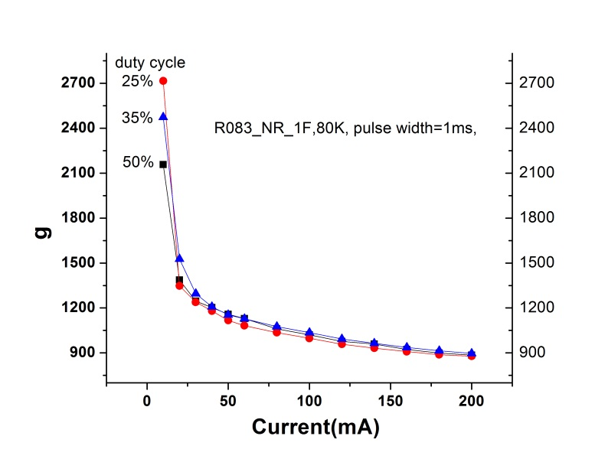

# 3 The mathematics in LIA

In the following 3 steps, I will prove that a P peak-peak square pulse input will result in a output of 

## 3.1 Periodic function and Fourier expansion

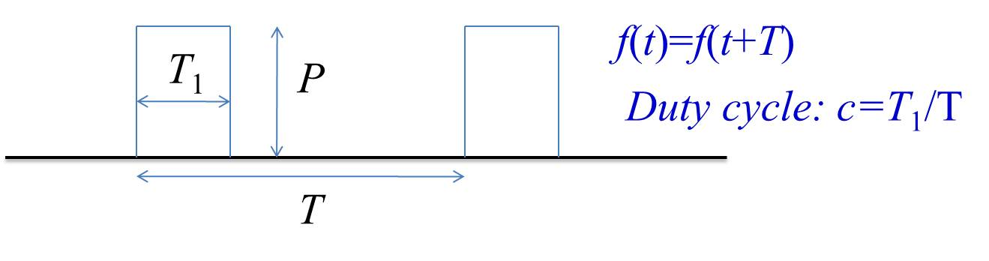











 is the first harmonic component in the signal.

## 3.2 PSD output

The **internal reference** is 

The **Phase-sensitive detector (PSD) output** is the product of two sine waves:



If the two frequencies equal and use a low pass filter, the output will be a **DC signal**:



Another PSD output is 

So X or Y output is phase dependent: .

But we are only interested in the **amplitud**e 

The LIA measures and displays input signal in Volts **rms**. So the **ultimate output** is 

## 3.3 Determine VL

Via a resistance of 50 ohm, we can infer from the following figure, VL is 2.

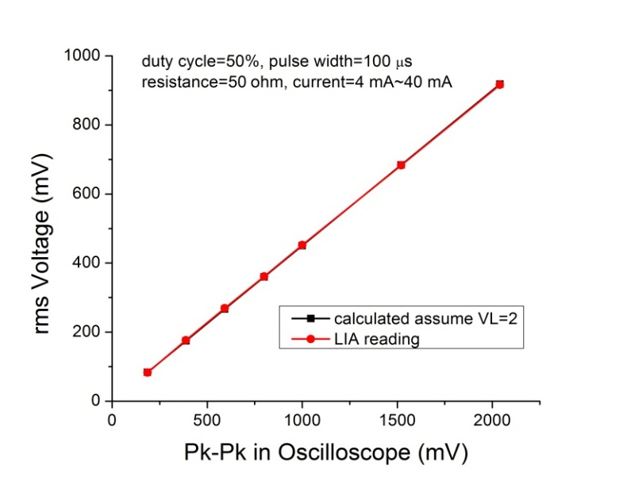

So **LIA output** is 

## Linear range

From the above figure, the linearity in LIA is good all the way to 1V. So the actual linearity depends on the **linear range of MCT detector**, as shown in the following (λ=10.6 µm).



The output is linear until 10 mV, which is equivalent to LIA read: 10*0.45=4.5 mV. Because of the variations in material composition and wavelength dependence, the “safe” linear range will be around **1 mV**.

## Signal frequency

In the calibration measurement, pulse width is of the order of ms. Because both LIA and MCT detector could only support signal frequency to maximum of 100 kHz (better below 10 kHz). So pulse width 1-3 ms, frequency 130-500 Hz (further lower frequency must use Notch filer). The frequency is not very crucial for power meter because it use thermopile sensor and it is an average effect (not require quick response).

## Complex format of Fourier expansion







, it should be doubled to add up the negative frequency

, so only real part is taken in the previous equation